Pass for level 7: 7z3hEENjQtflzgnT29q7wAvMNfZdh0i9

Step 1: entering to natas 6

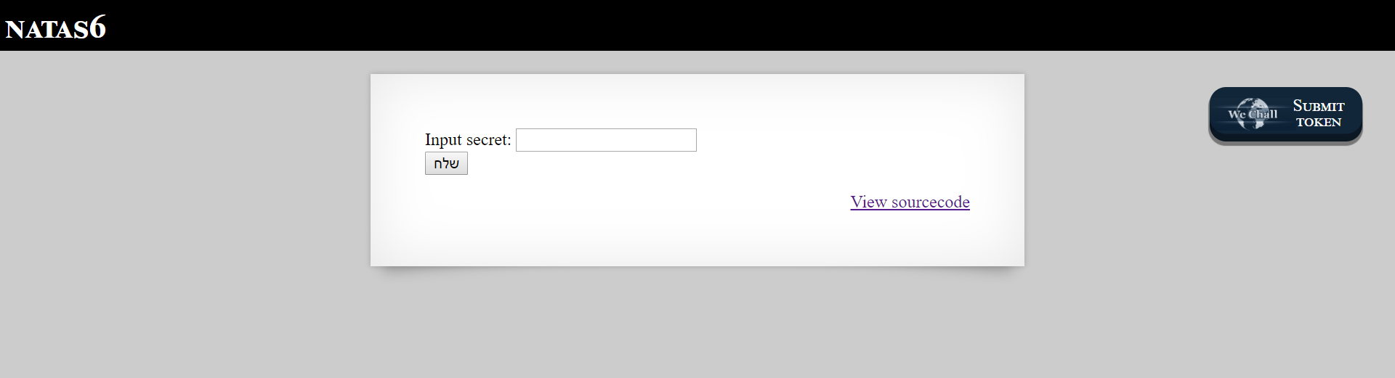

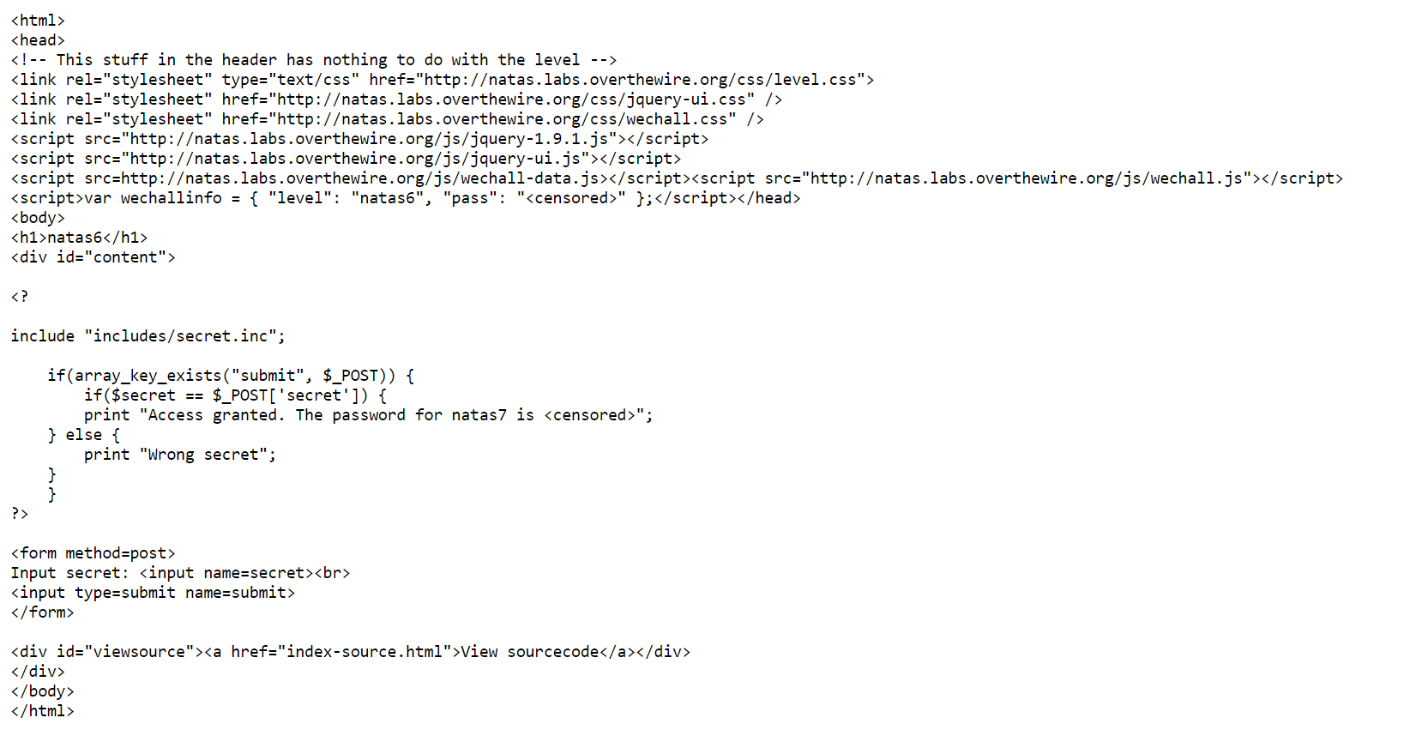

Step 2: while recognize that the code is whitened in php I curious about the include path from the web server.

I enter to the includes/secrete.inc path and expected to see the following:

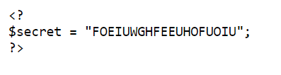

I copied the code FOEIUWGHFEEUHOFUOIU

Step 3:entering the code in the original natas6 web server

